ML Mini Project — Documentation
Name : Jayaram K S
Batch / Track : AI&DS-2026D6
Project title: Brightcart Customer Conversion Prediction
GitHub link: Click
Last updated: Sep 2026

1. Business Problem
What problem are you solving? (3–4 sentences)
Brightcart Online Retail wants to predict whether a website visitor is likely to make a purchase during a given visit window. The goal is to identify potential converters using customer information, browsing session behavior, and marketing interaction data. These predictions can help the marketing team target likely customers more effectively with retargeting campaigns. The classification model predicts the outcome as either
- Yes (will convert) or
- No (will not convert).

Who has this problem, and what is it costing them?
The marketing team at Brightcart has this problem because it needs to decide which visitors are worth targeting with limited marketing resources. Without accurate predictions, the company may waste advertising and retargeting resources on visitors who are unlikely to purchase. At the same time, failing to identify likely buyers can result in missed sales opportunities.

Why can't a simple rule or filter solve it?
A simple rule, such as targeting visitors who viewed many pages or visited frequently, may not capture the combination of factors that influence conversion. Customer characteristics, browsing behavior, and marketing interactions can interact in more complex ways. A machine-learning classification model can learn these patterns from historical data and make predictions for new customers.

2. What You Are Building
What will your model predict?
The model will predict whether a website visitor will make a purchase during the given visit window. The output will be either Yes (converted) or No (not converted).

Is it classification, regression, or clustering?
This is a binary classification problem because the target variable, converted, has two possible categories: Yes and No.

How would the business actually use the output?
Brightcart can use the model's predictions to identify visitors who are more likely to purchase and target them with retargeting campaigns or other marketing actions. This can help the marketing team use its budget more efficiently and focus attention on customers with a higher likelihood of conversion.

3. Data
Name of the datasets?
The project uses five datasets:
- customer_master.csv — customer account information
- session_logs.csv — website browsing/session activity
- marketing_touchpoints.csv — customer interactions with marketing channels
- converted_labeled.csv — customers with known conversion outcomes, used for training
- converted_to_predict.csv — customers without labels, for whom predictions are required
How many rows and columns?
The number of rows and columns for each dataset will be reported from the initial dataset inspection using shape, after reading csv to dataframe before any cleaning or merging.
customer_master (437, 5)
session_logs (4040, 4)
marketing_touchpoints (1835, 4)
converted_labeled (372, 2)
converted_to_predict (65, 1)

What is the target column?
The target column is converted. It indicates whether the customer made a purchase, with Yes representing a conversion and No representing no conversion.

How is the target distributed? (e.g. 88% No / 12% Yes)

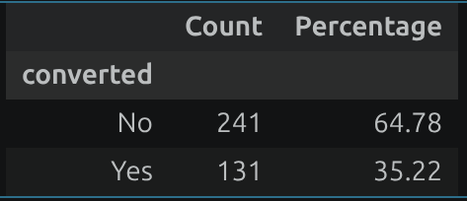

Which columns are you using, and what does each one mean?

Column | D.Type | Meaning
customer_id | str | Unique identifier for each customer
account_type | str | Type of customer account
region | str | Geographical region of the customer
referral_source | str | Source through which the customer was referred
days_since_last_visit | int64 | Number of days since the customer's last visit
converted | str | Target variable indicating whether the customer converted (Yes/No)
total_sessions | int64 | Total number of website sessions
total_pages_viewed | float64 | Total pages viewed across all sessions
avg_pages_viewed | float64 | Average number of pages viewed per session
max_pages_viewed | float64 | Maximum number of pages viewed in a single session
total_bounces | int64 | Total number of bounced sessions
bounce_rate | float64 | Proportion of sessions that resulted in a bounce
total_touchpoints | float64 | Total number of marketing interactions
avg_response_time | float64 | Average response time for marketing interactions
min_response_time | float64 | Minimum response time for marketing interactions
max_response_time | float64 | Maximum response time for marketing interactions
Email | float64 | Number of Email marketing interactions
Push Notification | float64 | Number of Push Notification interactions
Retarget Ad | float64 | Number of Retarget Ad interactions
SMS | float64 | Number of SMS marketing interactions
no_marketing | int64 | Indicator showing whether the customer had no marketing interactions (1 = no marketing, 0 = had marketing)

What is wrong with this data? (missing values, imbalance, old data, small size — be honest)
The dataset has several data-quality issues that need to be addressed before modeling. These include missing values, duplicate session records, invalid/negative values in pages_viewed, and a moderately imbalanced target variable (approximately 66% No and 34% Yes), Outliers for some numeric columns. The dataset is also relatively small, which may limit generalization. There is no sufficient evidence to conclude that the data is outdated, so this has not been treated as a confirmed issue.

4. Data Preparation
How did you handle missing values? (which columns, what method, why)
region → missing values replaced with "Unknown" because the missing category itself may carry information and we don't want to lose those customers.

referral_source → missing values replaced with "Unknown" for the same reason.

pages_viewed → negative values were treated as invalid and converted to missing, then missing values were replaced with the median because the median is less affected by extreme values.

Marketing response_time aggregate features → missing values were replaced with their median.

How did you handle outliers?

Negative values in pages_viewed were considered invalid and converted to missing before median imputation.

We did not remove valid high values as outliers because unusually high browsing activity could represent genuine customer behavior.

Therefore, we avoided unnecessarily deleting potentially useful observations.

How did you encode categorical columns? (one-hot, label, target encoding)
We used One-Hot Encoding for:
- account_type
- region
- referral_source
This converts categorical values into numerical columns that the ML models can use. We used handle_unknown="ignore" so unseen categories in the test/prediction data don't cause errors.
Did you scale anything? Which columns and why?
Yes. We used Min-Max Scaling on the numerical features.
This transforms numerical values to a common range, typically 0 to 1. It is particularly important for models such as KNN, SVM and Logistic Regression, where differences in feature scale can affect the model.
Did you create any new features? What and why?
Yes. We aggregated session and marketing data at the customer level.
Session features:
- total_sessions
- total_pages_viewed
- avg_pages_viewed
- max_pages_viewed
- total_bounces
- bounce_rate
Marketing features:
- total_touchpoints
- avg_response_time
- min_response_time
- max_response_time
- Email
- Push Notification
- Retarget Ad
- SMS
- no_marketing

These features summarize each customer's browsing behavior and marketing engagement so that there is one customer-level record for prediction.(One to one relation based on customer_id)

How did you split the data? (ratio, random_state, did you stratify)

We used an 80:20 train-test split:

80% → training data
20% → testing data
random_state=42 → makes the split reproducible.
stratify=y → preserves approximately the same Yes/No class distribution in both training and test sets.

5. What You Found in the Data
Pick 3 findings. One chart each, one line on what it means.

- Chart: Conversion Distribution (converted — Yes vs No)
- 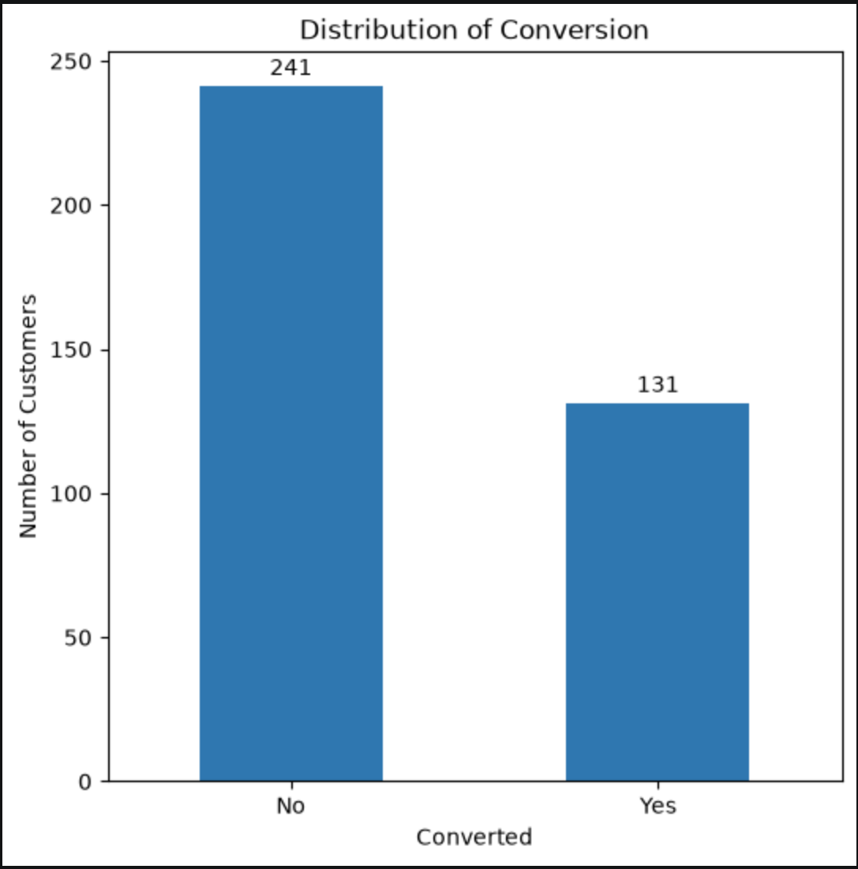
- What it means: The target is moderately imbalanced, with approximately 66% No and 34% Yes.

- Chart: Average Pages Viewed by Conversion
- 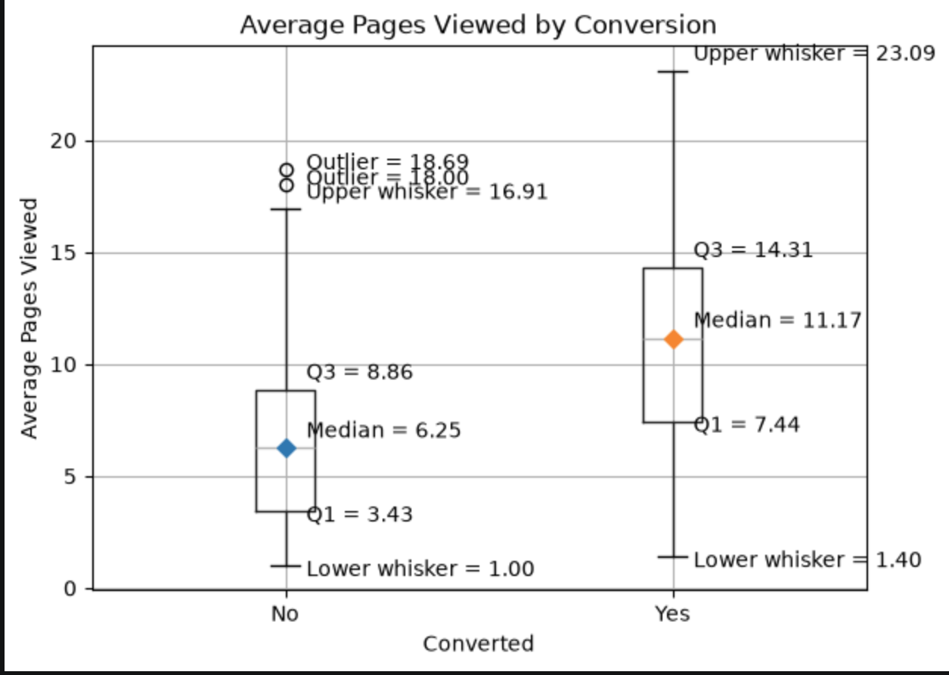
- What it means: Customers who converted viewed substantially more pages per session, with a median of 11.17 pages for Yes versus 6.25 for No, suggesting that higher browsing engagement is associated with conversion.

- Chart: Conversion Rate by Referral Source
- 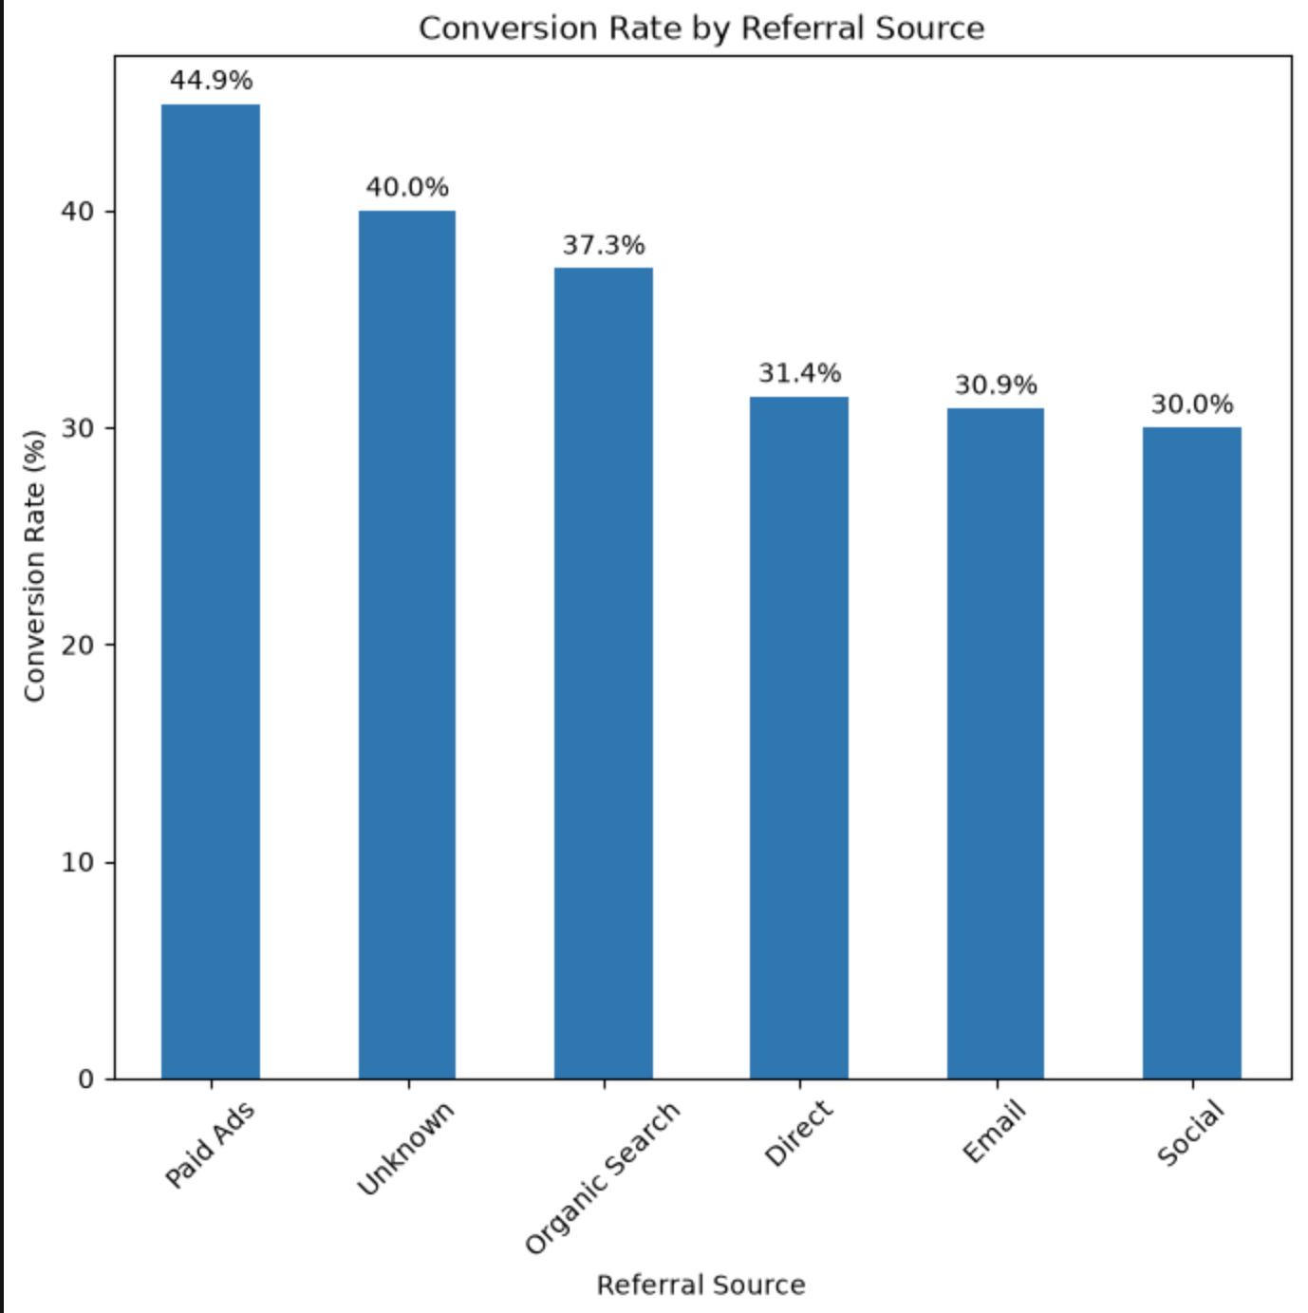
- What it means: Conversion rates vary across referral sources, with Paid Ads having the highest conversion rate (44.9%) and Social the lowest (30.0%), suggesting that referral source may provide useful information for predicting conversion.

6. Models
Baseline model and its score: (the simplest possible model — everything else must beat this)

Which models did you try?

Model | Why you chose it | Score | Notes
Baseline | Provides a simple benchmark by always predicting the majority class | ~66% Accuracy | Predicts No for every customer
Logistic Regression | Provides a simple linear classification approach | 68.00% Accuracy | Basic interpretable ML model
Decision Tree | Can capture non-linear relationships and feature interactions | 66.67% Accuracy | Easy to interpret
Random Forest | Combines multiple decision trees to improve robustness | 73.33% Accuracy | Strong tree-based model
KNN | Provides a distance-based classification approach | 57.33% Accuracy | Performed poorly
SVM | Can learn complex class boundaries | 66.67% Accuracy | Low recall for Yes
Gradient Boosting | Builds models sequentially to correct previous errors | 70.67% Accuracy | Good ensemble model
AdaBoost | Focuses more on observations that are difficult to classify | 74.67% Accuracy | Strong performance
Naive Bayes | Provides a probabilistic classification approach | 68.00% Accuracy | Simple probabilistic model
AdaBoost Tuned | Tests whether changing AdaBoost parameters improves performance | 77.33% Accuracy | Best-performing model

How did you tune it? (GridSearchCV / RandomizedSearchCV / manual — and the best parameters found)
We used manual tuning for AdaBoost rather than GridSearchCV or RandomizedSearchCV.
The selected parameters were:
AdaBoostClassifier( n_estimators=100, learning_rate=0.2, random_state=42 )
The tuned AdaBoost achieved:
- Accuracy: 77.33%
- Precision: 69.57%
- Recall: 61.54%
- F1-score: 65.31%

7. Evaluation
Which metric did you use?
We evaluated the models using Accuracy, Precision, Recall, and F1-score, along with the confusion matrix.

Why that metric and not accuracy?
Accuracy alone can be misleading because the target is moderately imbalanced (66% No / 34% Yes). Since identifying customers who will convert is important, we paid particular attention to Recall and F1-score for the Yes class. Recall is important because a false negative means missing a customer who actually converts.

Confusion matrix / error plot:
For the final AdaBoost Tuned model:
 | Predicted No | Predicted Yes
Actual No | TN = 42 | FP = 7
Actual Yes | FN = 10 | TP = 16

Where does the model get things wrong most often?
The model makes more errors by missing actual converters (FN = 10) than by incorrectly identifying non-converters as converters (FP = 7). This means the model still misses some potential customers who would have converted.

Final model selected, and why:
AdaBoost Tuned was selected as the final model because it achieved the highest overall performance among the tested models:
- Accuracy: 77.33%
- Precision: 69.57%
- Recall: 61.54%
- F1-score: 65.31%
It also substantially outperformed the approximately 66% majority-class baseline.

8. Findings & Business Benefit
What does your score mean in plain words? Example: "Recall of 0.71 means the model catches about 7 of every 10 customers who are about to leave."

The final Tuned AdaBoost model has a recall of 61.54% for customers who convert. This means the model correctly identifies about 6 out of every 10 actual converters.
Its precision of 69.57% means that when the model predicts a customer will convert, about 7 out of 10 of those predictions are correct.
The model achieved an F1-score of 65.31%, showing a reasonable balance between identifying converters and avoiding unnecessary targeting.

What can the business do differently now?
Brightcart can use the model to identify customers who are more likely to convert and prioritize them for retargeting campaigns.

Who would use this, and how often?
The marketing and customer-retention teams would use the predictions.
The model could be run regularly, such as daily or weekly, using the latest customer activity. The resulting predictions can then be used to decide which customers should receive targeted marketing or retargeting campaigns.

9. Challenges Faced
Minimum 3. Include what didn't work — that's the useful part.

Challenge 1
Stage | Data Cleaning
Problem | Some session records contained negative values for pages_viewed, which are not valid. There were also duplicate session records.
What you tried | The invalid values were initially treated as missing, and the session data was checked for duplicates.
What worked | Negative pages_viewed values were replaced with missing values and then median-imputed. Duplicate session records were removed.
Result | The session data was cleaned without removing potentially valid high page-view values.

Challenge 2
Stage | Data preparation
Problem | Several categorical and numerical features contained missing values, including region, referral_source, and marketing response times.
What you tried | Missing categorical values were examined separately from numerical missing values.
What worked | Categorical missing values were replaced with "Unknown" and numerical values were median-imputed. Categorical variables were then one-hot encoded and numerical variables were Min-Max scaled.
Result | The dataset could be used consistently by all the classification models without missing-value errors.

Challenge 3
Stage | Modelling / Evaluation
Problem | The models produced noticeably different results, and some models performed poorly at identifying customers who actually converted. KNN, for example, achieved only 15.38% recall for the Yes class.
What you tried | Several classification algorithms were tested, including Logistic Regression, Decision Tree, Random Forest, KNN, SVM, Gradient Boosting, AdaBoost, and Naive Bayes. AdaBoost was then manually tuned.
What worked | Tuning AdaBoost with n_estimators=100 and learning_rate=0.2 improved its overall performance.
Result | Tuned AdaBoost achieved the best F1-score of 65.31% and accuracy of 77.33%, so it was selected as the final model.

If something was never solved, still write it here and put "not solved" under What worked.

10. Limitations & Next Steps
What can this project not do?
The model can predict which customers are more likely to convert, but it cannot guarantee that a customer will purchase. The dataset is also relatively small, so model performance may vary when applied to a larger or different group of customers.

Three things you'd fix with more time:

1. Improve model tuning
Test more hyperparameter combinations and use cross-validation to find more reliable model settings.

2. Improve feature engineering
Create additional useful customer-level features from session and marketing data, such as more detailed engagement measures, if the raw data supports them.

3. Improve handling of false negatives
Since missed converters can mean lost sales, experiment with probability thresholds or class weighting to improve recall for the Yes class while keeping precision at a useful level.

11. Tech Stack
Language and version: Python 3.13.9

Libraries used:

- Pandas — data loading, cleaning, merging, and feature engineering
- Scikit-learn — preprocessing, train/test split, classification models, and evaluation metrics
- Matplotlib — data visualization and EDA
- IPython — notebook display formatting

12. GitHub README Checklist
Tick each once it's in your repo README.

- Project title and one-line description
- Business problem in 3–4 sentences
- Dataset — source, link, size
- Tech stack and libraries
- How to run it
- Results — main metric and what it means
- 2–3 key charts
- Folder structure
- Limitations / future work

Before You Submit
- Baseline model reported in Section 6
- Metric choice explained in Section 7
- At least 3 challenges, including failed attempts
- Limitations filled in honestly
- GitHub repo is public and runs end to end
- All charts have titles and axis labels

